**Pizza Sales Report Queries**

**KPIs:**

**1. Total Revenue:**

SELECT SUM(total_price) AS Total_Revenue FROM pizzasales;

**Output:**

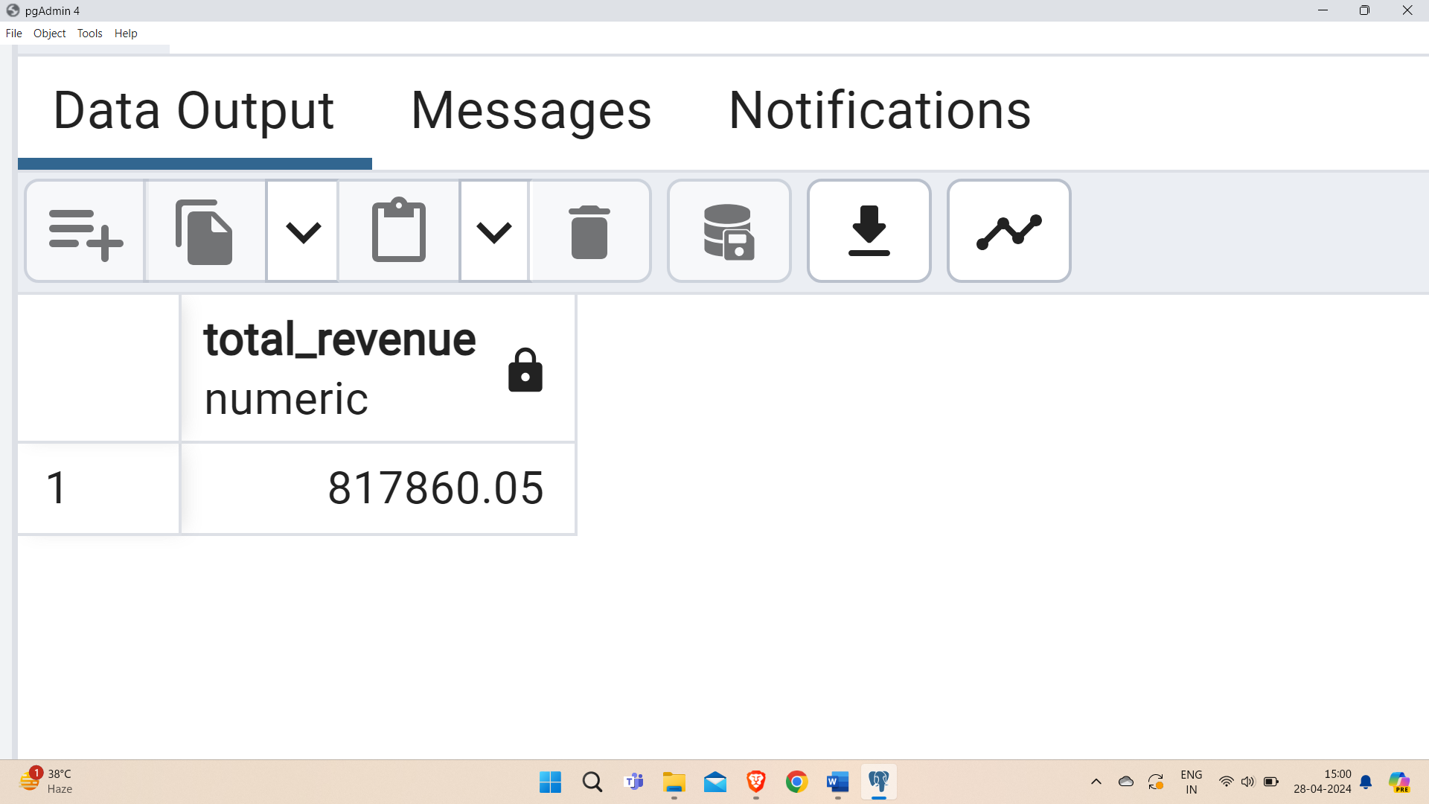

**2. Average Order Value:**

SELECT (SUM(total_price) / COUNT(DISTINCT order_id)) AS Avg_order_Value FROM pizzasales;

**Output:**

**3. Total Pizzas Sold:**

SELECT SUM(quantity) AS Total_pizza_sold FROM pizzasales;

**Output:**

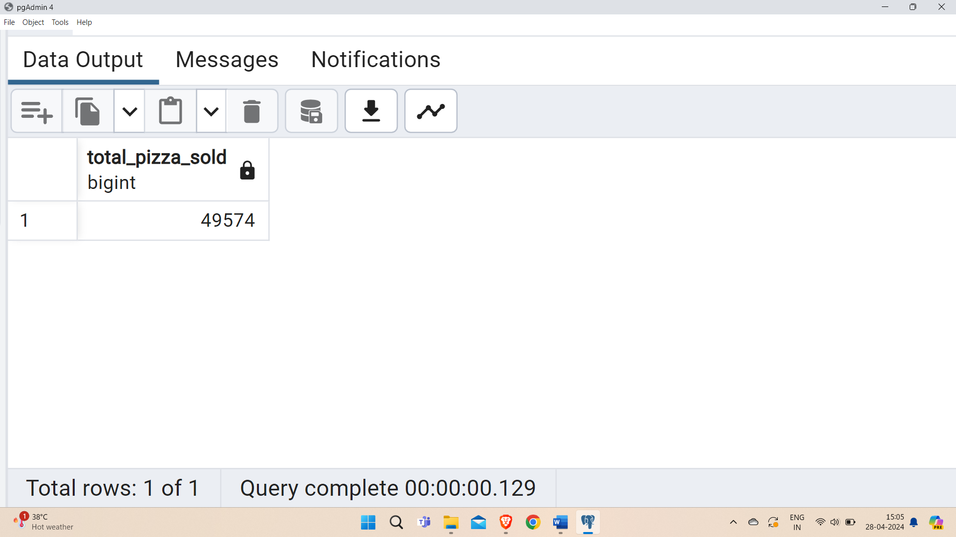

**4. Total Orders:**

SELECT COUNT(DISTINCT order_id) AS Total_Orders FROM pizzasales;

**Output:**

**5. Average Pizzas Per Order:**

SELECT CAST(CAST(SUM(quantity) AS numeric(10,2)) /

CAST(COUNT(DISTINCT order_id) AS numeric(10,2)) AS numeric(10,2))

AS Avg_Pizzas_per_order

FROM pizzasales;

**Output:**

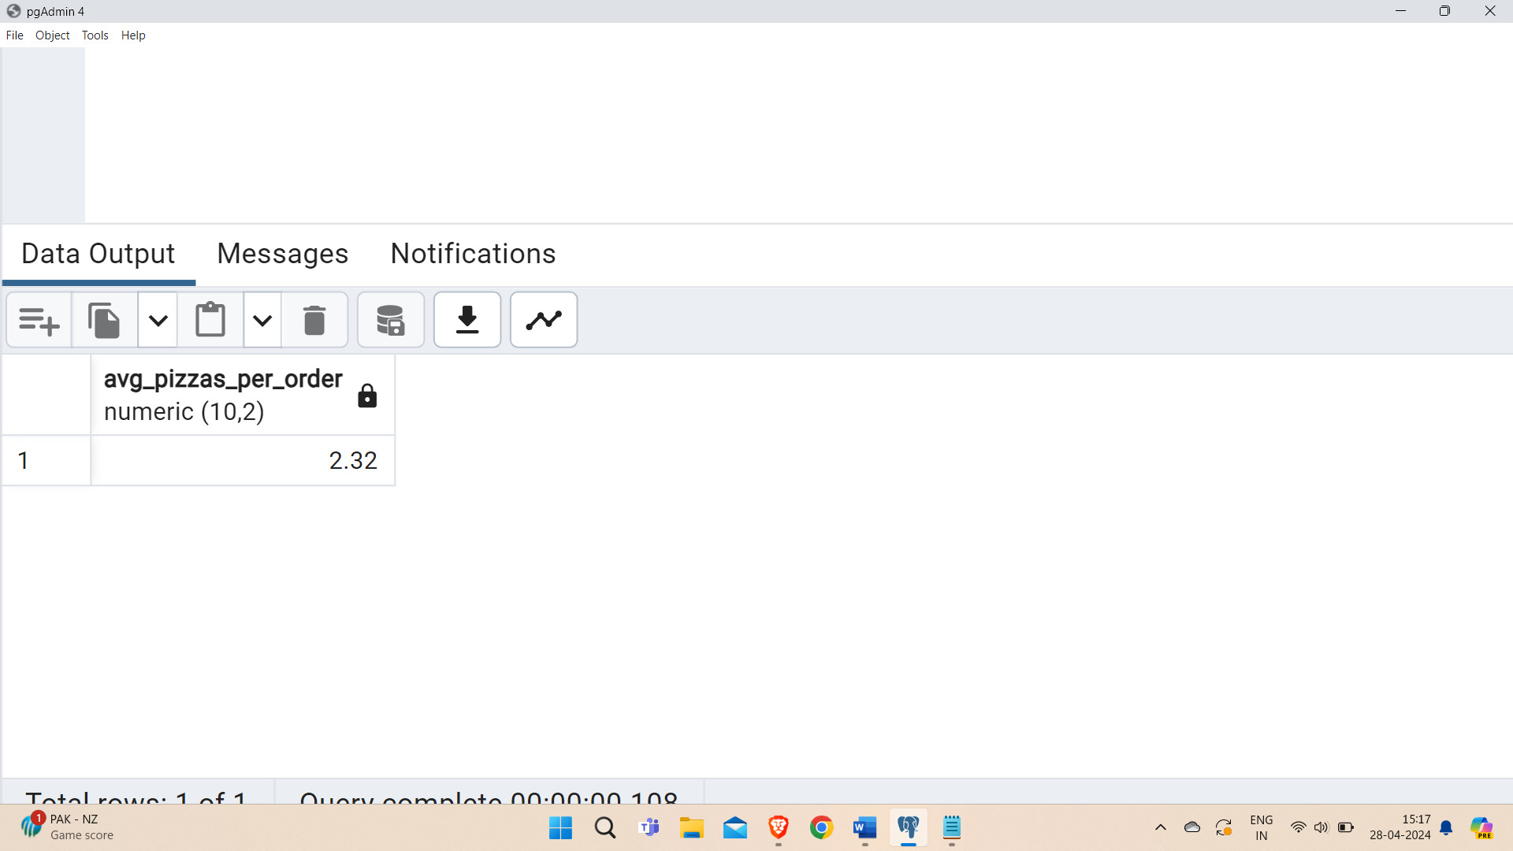

**Hourly trend for total pizzas sold**

SELECT extract(HOUR from order_time) as order_hours, SUM(quantity) as total_pizzas_sold

from pizzasales

group by extract(HOUR from order_time)

order by extract(HOUR from order_time);

**Output:**

**Weekly trend for orders**

SELECT

extract(week from order_date) AS WeekNumber,

extract(year from order_date) AS Year,

COUNT(DISTINCT order_id) AS Total_orders

FROM

pizzasales

GROUP BY

extract(week from order_date),

extract(year from order_date)

ORDER BY

Year, WeekNumber;

**Output:**

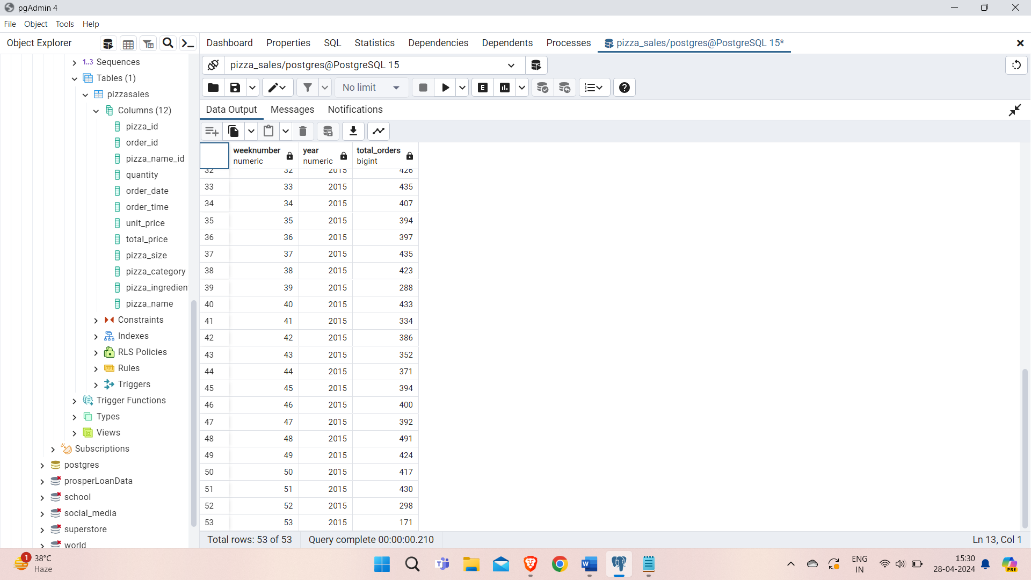

**% of Sales by Pizza Category**

SELECT pizza_category, CAST(SUM(total_price) AS numeric(10,2)) as total_revenue,

CAST(SUM(total_price) * 100 / (SELECT SUM(total_price) from pizzasales) AS numeric(10,2)) AS PCT

FROM pizzasales

GROUP BY pizza_category;

**Output:**

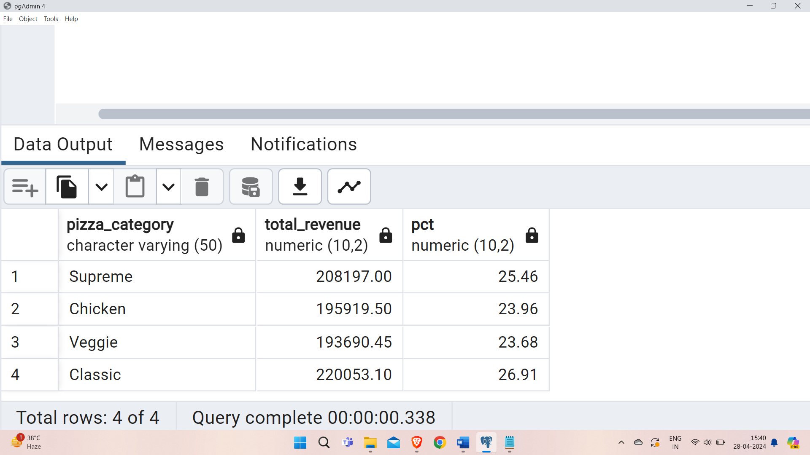

**% of Sales by Pizza Size**

SELECT pizza_size, CAST(SUM(total_price) AS NUMERIC(10,2)) as total_revenue,

CAST(SUM(total_price) * 100 / (SELECT SUM(total_price) from pizzasales) AS NUMERIC(10,2)) AS PCT

FROM pizzasales

GROUP BY pizza_size

ORDER BY pizza_size;

**Output:**

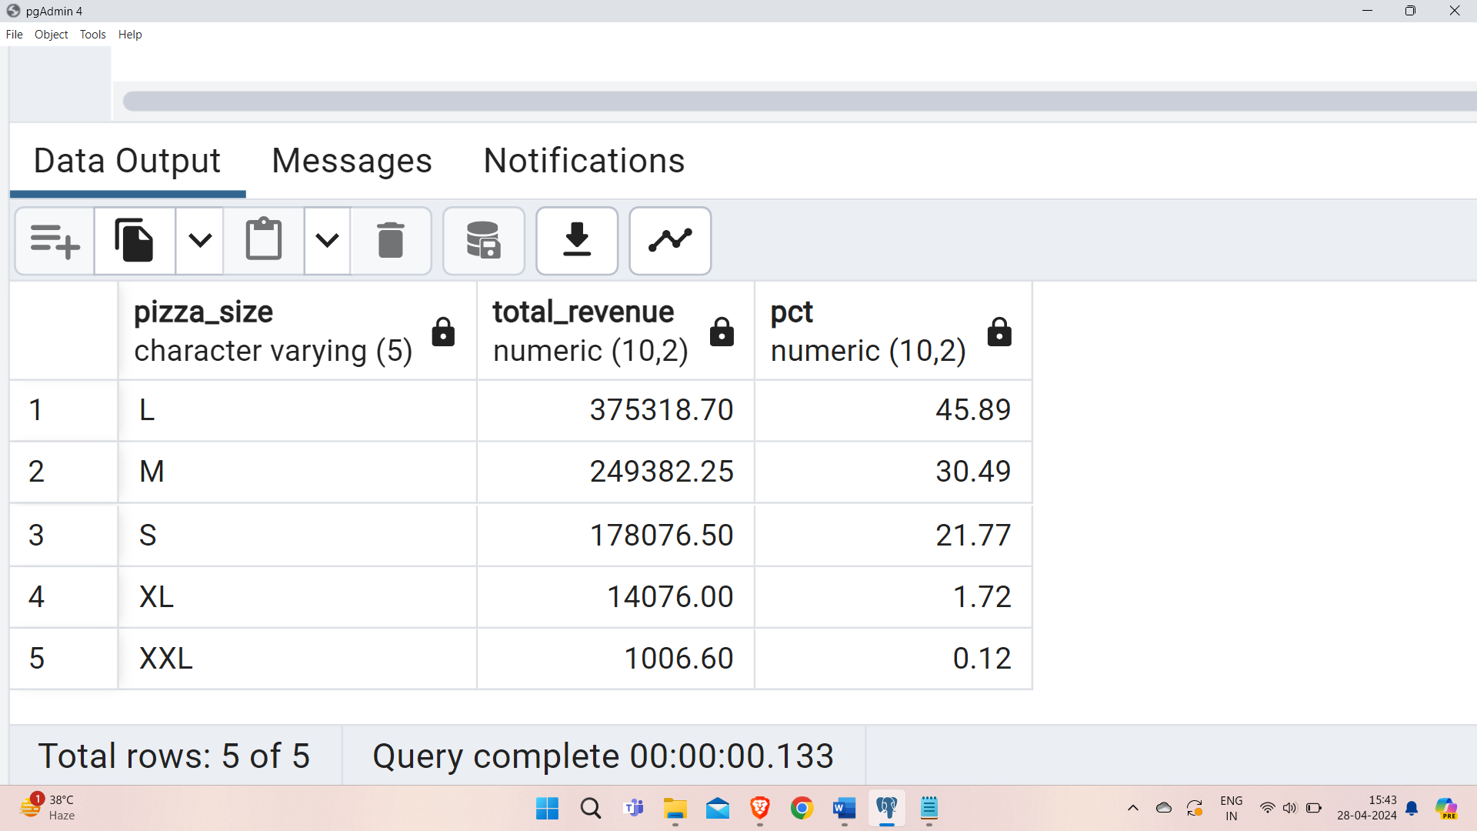

**Total Pizzas Sold by Pizza Category**

SELECT pizza_category, SUM(quantity) as Total_Quantity_Sold

FROM pizzasales

GROUP BY pizza_category

ORDER BY Total_Quantity_Sold DESC;

**Output:**

**Top 5 Pizzas by Revenue**

SELECT pizza_name, SUM(total_price) AS Total_Revenue

FROM pizzasales

GROUP BY pizza_name

ORDER BY Total_Revenue DESC

LIMIT 5;

**Output:**

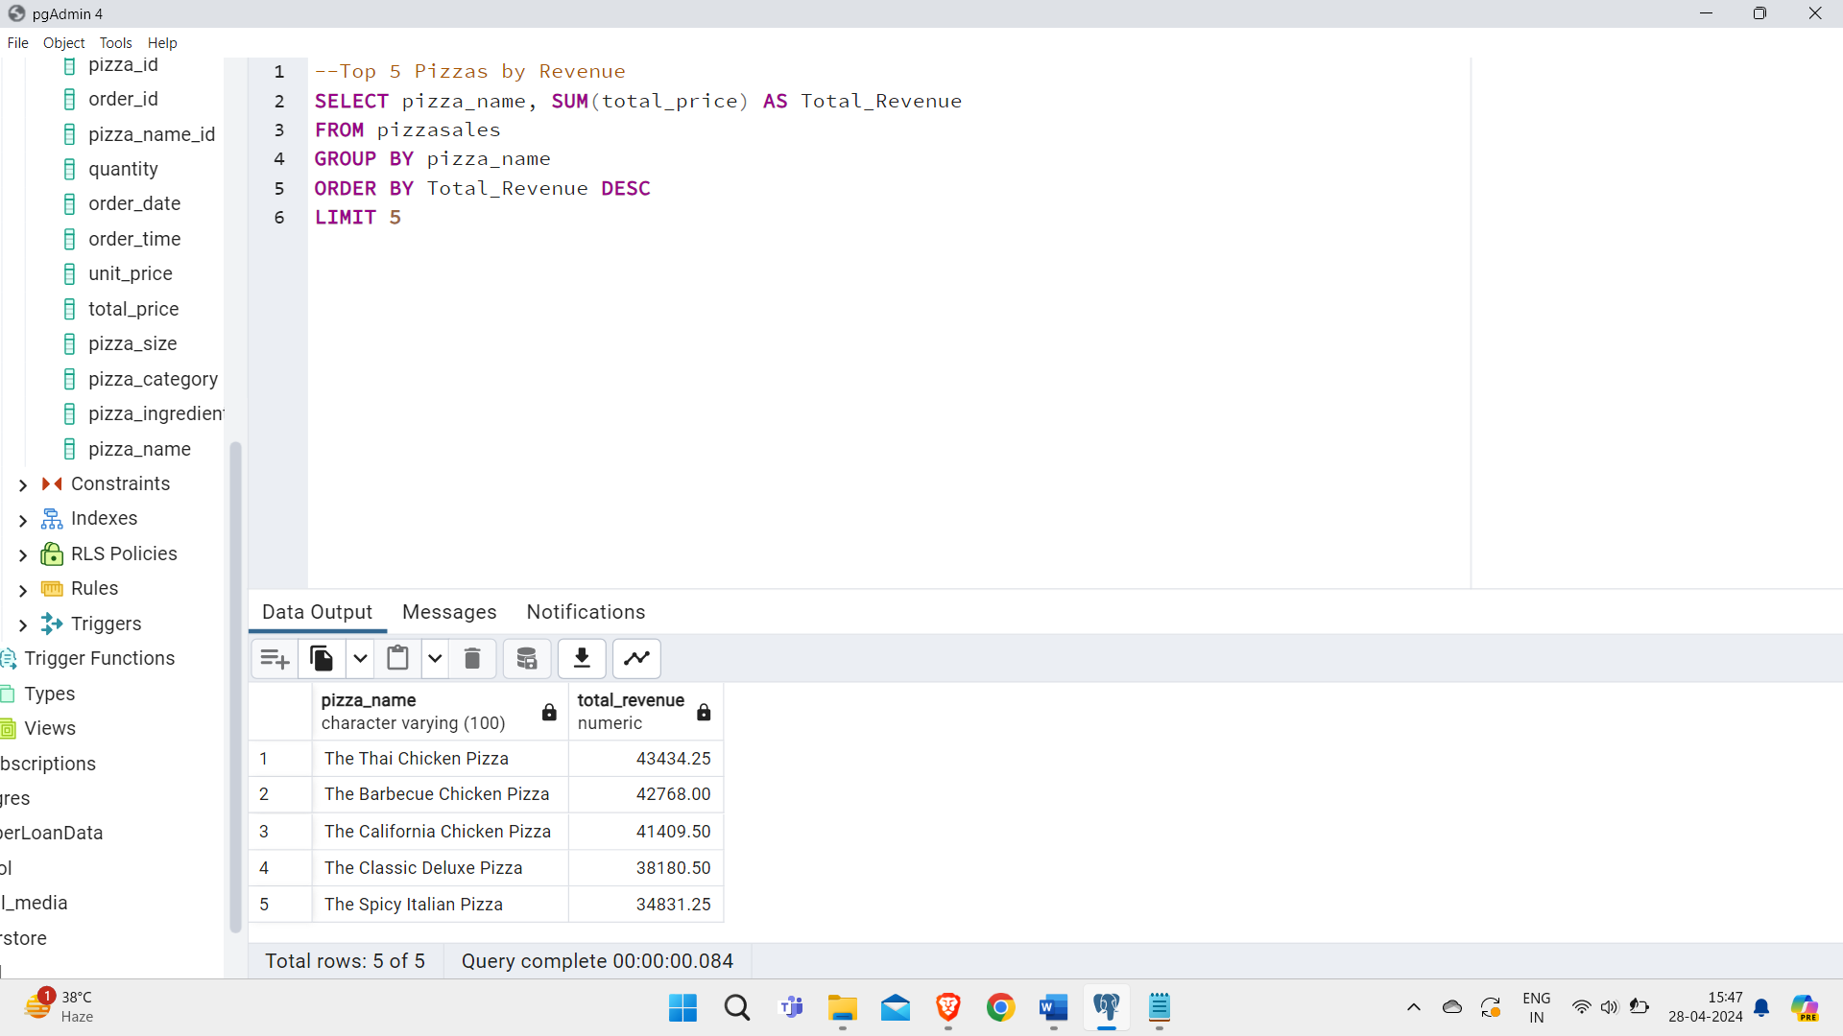

**Bottom 5 Pizzas by Revenue**

SELECT pizza_name, SUM(total_price) AS Total_Revenue

FROM pizzasales

GROUP BY pizza_name

ORDER BY Total_Revenue ASC

LIMIT 5;

**Output:**

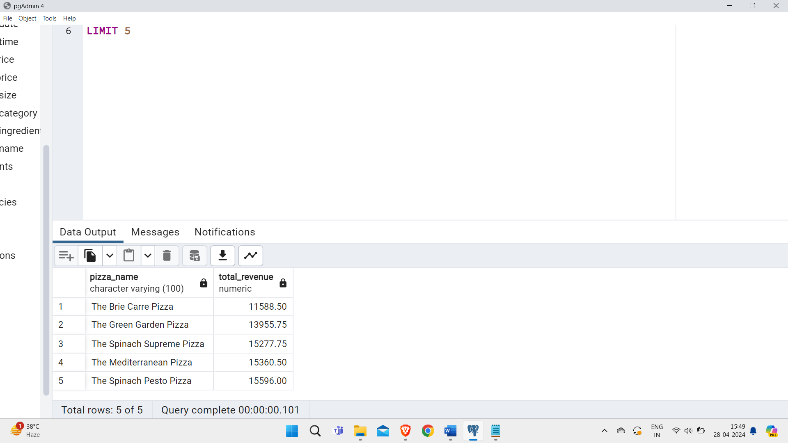

**Top 5 Pizzas by Quantity**

SELECT pizza_name, SUM(quantity) AS Total_Pizza_Sold

FROM pizzasales

GROUP BY pizza_name

ORDER BY Total_Pizza_Sold DESC

LIMIT 5;

**Output:**

**Bottom 5 Pizzas by Quantity**

SELECT pizza_name, SUM(quantity) AS Total_Pizza_Sold

FROM pizzasales

GROUP BY pizza_name

ORDER BY Total_Pizza_Sold ASC

LIMIT 5;

**Output:**

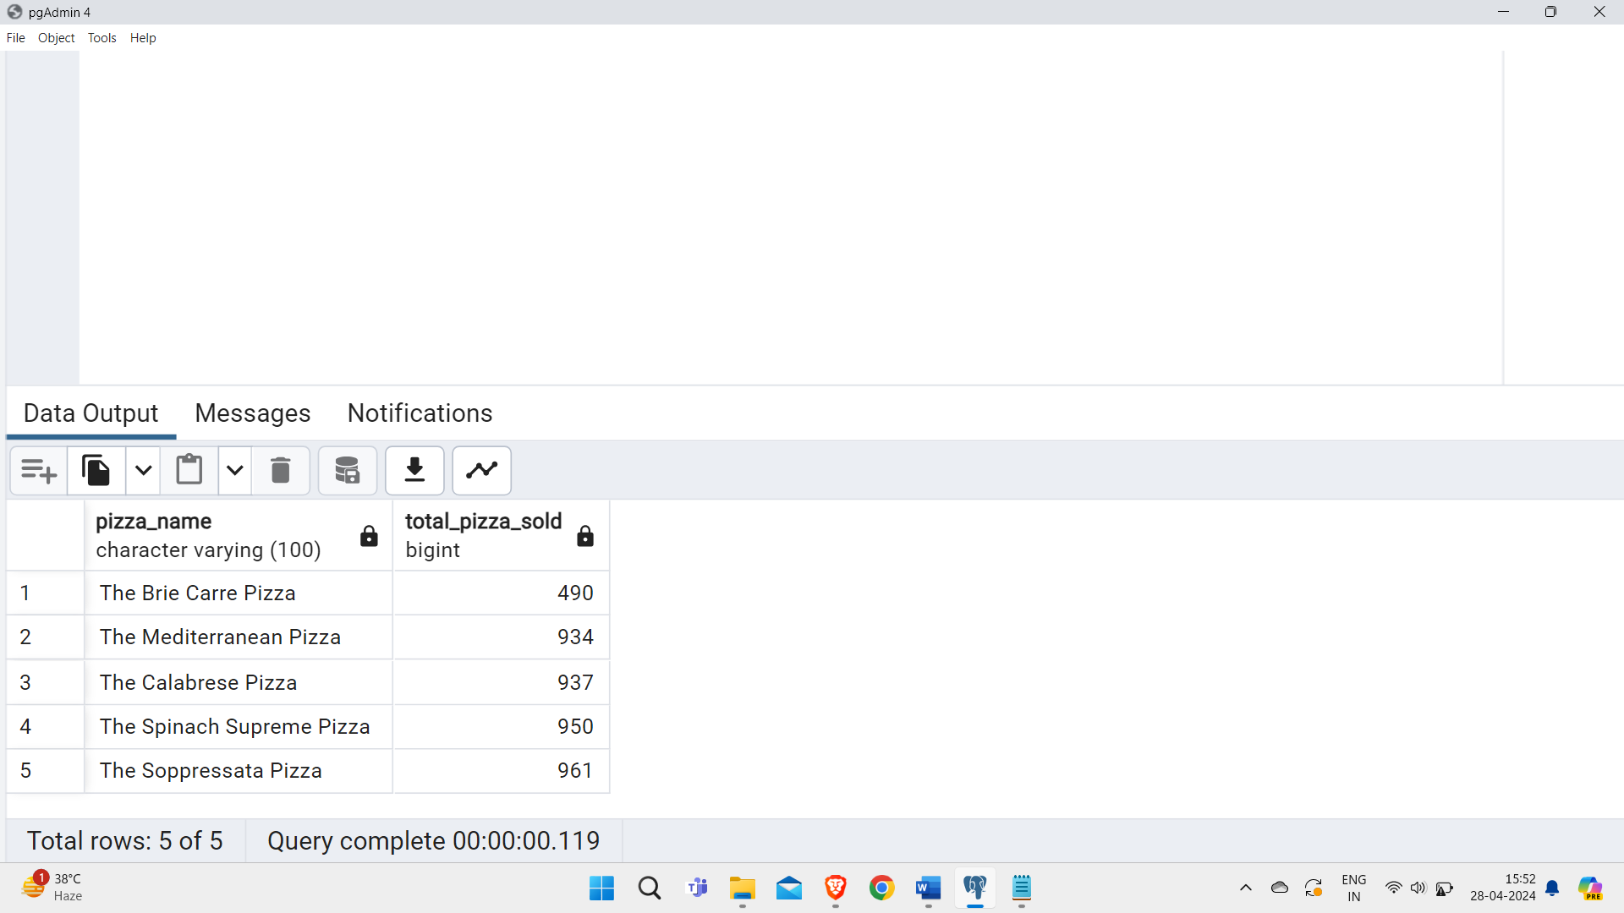

**Top 5 Pizzas by Total Orders**

SELECT pizza_name, COUNT(DISTINCT order_id) AS Total_Orders

FROM pizzasales

GROUP BY pizza_name

ORDER BY Total_Orders DESC

LIMIT 5;

**Output:**

**Bottom 5 Pizzas by Total Orders**

SELECT pizza_name, COUNT(DISTINCT order_id) AS Total_Orders

FROM pizzasales

GROUP BY pizza_name

ORDER BY Total_Orders ASC

LIMIT 5;

**Output:**

